**AUTOMATIC DOORBELL USING ARDUINO NANO**

**1Mr. A.Niranjan 2V.K. Ramdas Coudinya 3R.V. Sarath Kumar 4T. Ravi Teja**

1Assistant Professor, Department of Electronics & Communication Engineering, SCSVMV, Kanchipuram, India.

2,3,4 UG Scholar, Department of Electronics & Communication Engineering, SCSVMV, Kanchipuram, India.

**Abstract:**

* In this project, we will be designing an advanced doorbell that ensures safety from COVID-19 pandemic as it is fully touch proof. What If the person who came to our house cannot find the doorbell or if the person has fever or if they maybe covid affected, what can be done to ensure?
* How will it be if we use an automatic doorbell which checks their temperature and gives us instructions whether it is safe or not to let them inside and ring the bell only when he is good? There are no more hassles.
* The person who comes to our house need not search for the doorbell and press it anymore. If we install this automatic doorbell using an object detection circuit on the door itself, the circuit will automatically sense the presence of the person and ring the doorbell.

**Introduction:**

The necessity for some means by which someone on the outside of a door could notify someone on the inside of his presence has been recognized for centuries.

The earliest solution to this problem consisted of the simple expedient of knocking on the door with one's fist. As humans grew in wisdom and technical sophistication, new and subtler methods were invented. They are:

* The first of these was the mechanical door knocker, which saved man untold pain from bruised knuckles.
* Then came the mechanical switch method that requires that a mat containing many such switches be placed in front of the door in such a way that anyone approaching the door must step on it. Not only are such mats highly unesthetic, but it must be connected to the sound producing unit inside the house, requiring that a hole be drilled through a wall. This sort of installation is beyond what most homeowners have the time or skill to attempt, and is therefore usually done by professionals, greatly increasing total cost.
* The photoelectric method requires that a light source and photodetector be mounted on either side of the path leading to the door. Here again, installation is usually done by professionals, and unless it is possible to hide the units in shrubbery, the light source and detector can be even more unesthetic than a mat.
* Installation of a doorbell based on a capacitance proximity sensor is somewhat simpler than that of a mechanical switch or photoelectric unit in that the entire device can be mounted on the inside of the door. However, in order to obtain even the minimal detection range of two feet, metal sensor plates of several square feet must be used, and while these cannot be seen from the outside, they are painfully obvious from the inside.

In order to overcome the disadvantages of the methods discussed, the ideal ***automatic doorbell*** would consist of a single small battery-operated unit or an adapter, requiring minimal electrical connections.

Installation would consist of driving a nail into the door and hanging the unit from it. The automatic doorbell herein described seeks to meet these criteria.

**BLOCK DIAGRAM:**

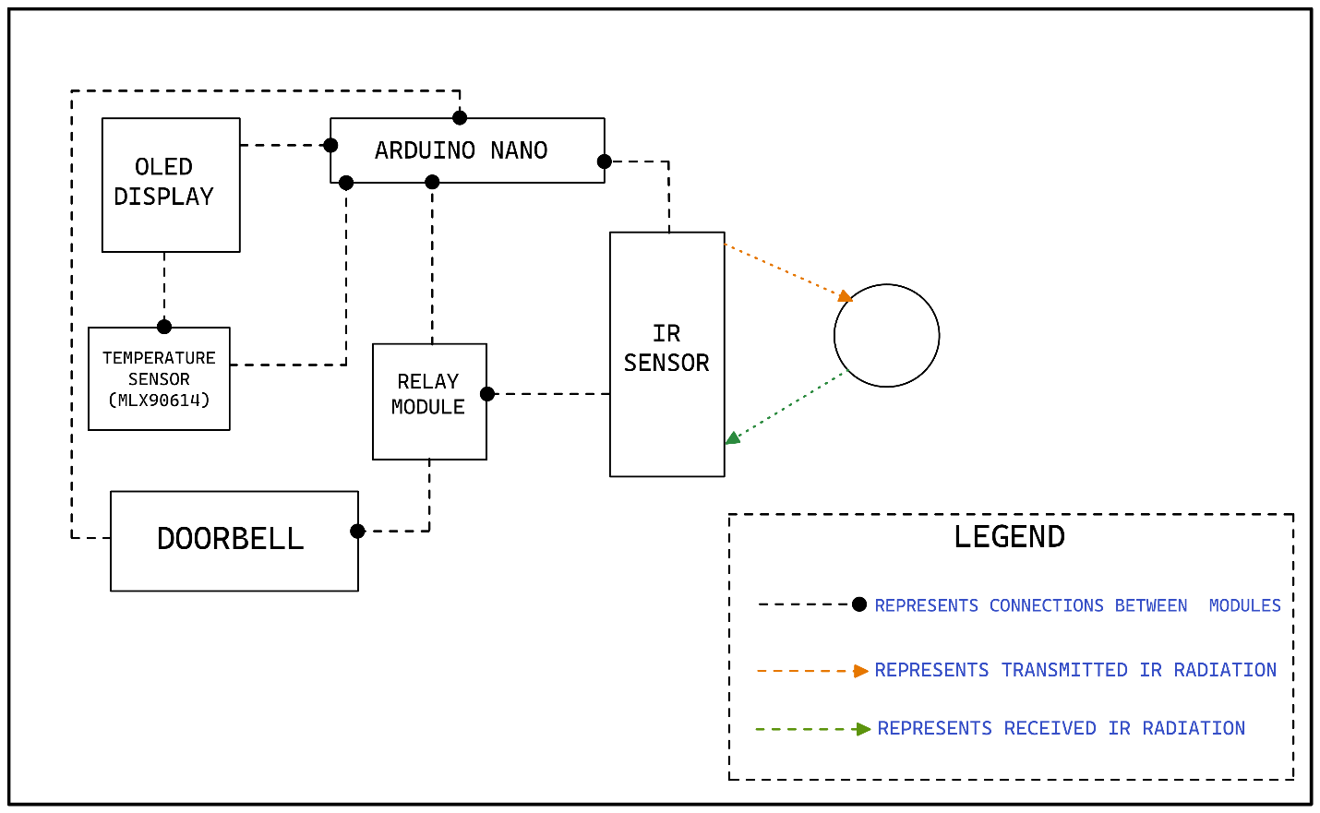

**Explanation of the block diagram:**

* **OLED Display:**

The OLED (Organic Light-Emitting Diode) display is an alternative for LCD display.

The OLED is super-light, almost paper-thin, flexible, and produces a brighter, crisper and a better picture.

* **Bread Board:**

A breadboard, or protoboard, is a construction base for prototyping of electronics.

* **ARDUINO NANO:**

The Arduino Nano is a small, complete, and breadboard-friendly board based on the ATmega328 (Arduino Nano 3.x). It has the same functionality of the Arduino UNO or

MEGA, but in a different package. It lacks only a DC power jack and works with a Mini-B USB cable instead of a standard one.

* **IR sensor:**

An infrared sensor (IR sensor) is a radiation-sensitive optoelectronic component with a spectral sensitivity in the infrared wavelength range 780 nm-50 µm. IR sensors are now widely used in motion detectors, which are used in building services to switch on lamps or in alarm systems to detect unwelcome guests.

* **Temperature Sensor (MLX90614):**

The MLX90614 sensor uses non-contact temperature sensing to collect temperature information without touching any specific surface. Although invisible to the human eye, all objects emit infrared light, and the concentration varies with temperature.

* **Doorbell/ Buzzer:**

The buzzer is a sounding device that can convert audio signals into sound signals. It is usually powered by DC voltage. It is widely used in alarms, computers, printers and other electronic products as sound devices.

* **Relay Module:**

A 5v relay is an automatic switch that is commonly used in an automatic control circuit and to control high-current using a low-current signal. The input voltage of the relay signal ranges from 0 to 5V.

**Working:**

When an object comes in the defined range of an IR sensor, the sensor detects the object and triggers the temperature sensor. Now, the temperature sensor (MLX90614) measures the temperature of the object.

If the measured temperature of the object is less than or equal to the defined temperature (i.e., 38°C is the defined temperature of a normal human body), the relay module will be triggered, and the bell will ring. Also, the temperature of the object and

**"WELCOME"** message will be printed on the OLED display welcoming them into the house.

If the measured temperature of the object is greater than the defined temperature the relay module will not trigger and hence the bell will not ring. Also, a message

**"High Temperature! Go Away!"** will be displayed.

**Results:**

* **Case 1 (Measured temperature of the object is less than or equal to the defined temperature):**

* **Case 2 (Measured temperature of the object is greater than the defined temperature):**

**Conclusion:**

Hence, we can conclude that:

* As there is a temperature sensor in this doorbell, we can easily identify people with high temperatures and save ourselves from getting infected.
* Safety is guaranteed.
* It is easy to install, is portable and is affordable.
* It also saves electricity, searching time for doorbells and manpower.
* The only disadvantage that a wireless doorbell is that it most often works on batteries. Now we don’t always check the battery charge of our doorbell every day. Consider the case when the battery gets discharged and if we are not conscious of this fact, what follows may be troublesome. A visitor might come, and we might not be aware of it as our doorbell is dead, but this is a small disadvantage that can be ignored as theadvantages of having a wireless doorbell are numerous. So, this one problem cannot make the entire product offering obsolete.

**Future Scope:**

* This research can be further extended by linking it to devices through IOT. This will help in reducing the manpower to check the temperature. In the future aspect it can connect to the emergency medical services.
* In general, this product will provide an extra layer of safety from COVID-19 infection by making automatic decisions through the developed system as there is potential chance of new variants of COVID may arise in the coming days, the process of primary detection of temperature is very important. This can be easily done by this automated doorbell.

**References:**

* Arduino based Wireless Doorbell: [www.electronicshub.org/wireless-door-bell](http://www.electronicshub.org/wireless-door-bell).
* Ambika, Baswaraj Gadget, Veeresh Pujari, Pallavi B V “Smart Bell Using IOT” International Journal for Research in Applied Science & Engineering Technology (IJRASET) (2017).
* Woo-hyuk Park and yun-gyung cheong “IoT smart bell notification system: Design and implementation” 19th International Conference on Advanced Communication Technology (ICACT) (2017).
* Jie-Ci Yang, Chin-Lun Lai, Hsin-Teng Sheu and Jiann-Jone Chen “An Intelligent Automated Door Control System Based on a Smart Camera” <http://www.mdpi.com/journal/sensors> (2016).
* Arduino based Wireless Doorbell (By Anusha) <https://www.electronicshub.org/arduino-based-home-automation-using-tv-remote/>